**Project Design Phase-II**

**Data Flow Diagram & User Stories**

|  |  |
| --- | --- |
| Date | 22 May 2023 |
| Team ID | NM2023TMID11307 |
| Project Name | Estimation and Prediction of Hospitalization and Medical Care Costs |

**Data Flow Diagrams:**

A Data Flow Diagram (DFD) is a traditional visual representation of the information flows within a system. A neat and clear DFD can depict the right amount of the system requirement graphically. It shows how data enters and leaves the system, what changes the information, and where data is stored.

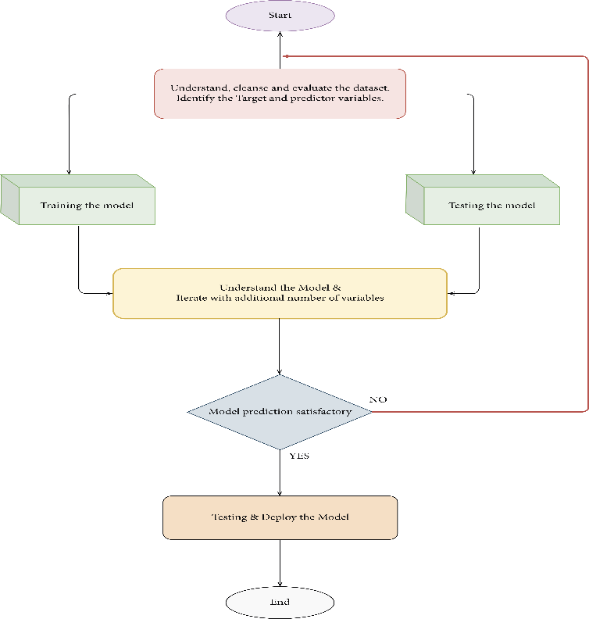

**User Stories**

Use the below template to list all the user stories for the product.

| **User Type** | **Functional Requirement (Epic)** | **User Story Number** | **User Story / Task** | **Acceptance criteria** | **Priority** | **Team Member** |
| --- | --- | --- | --- | --- | --- | --- |
| Student | Registration | USN-1 | As a user, I can register for the application by entering my email, password, and confirming my password. | I can access my dashboard or account. | High | Shahana |
| Student | Login | USN-2 | After registering for the application, I as a user will receive a confirmation email. | I can get a confirmation email and confirm it | High | Naresh |
| Student | Verification | USN-3 | The process of ensuring that the data entered or saved in a system or database is correct, complete, and consistent. | I can confirm the student's identification is accurate. | Low | Jayabharathi |
| Student | Marks | USN-4 | Exams are administered using a system called the Student Mark Analysis System. | I can confirm that the pupils' grades and marks are accurate. | Medium | Shahana |
| Student | Acess the database | USN-5 | All data is securely stored in the MySQL database, which is managed by the college administrator | I have access to the database of students. | High | HariHaran |